CS 255 System Design Document Template

UML Diagrams

UML Use Case Diagram
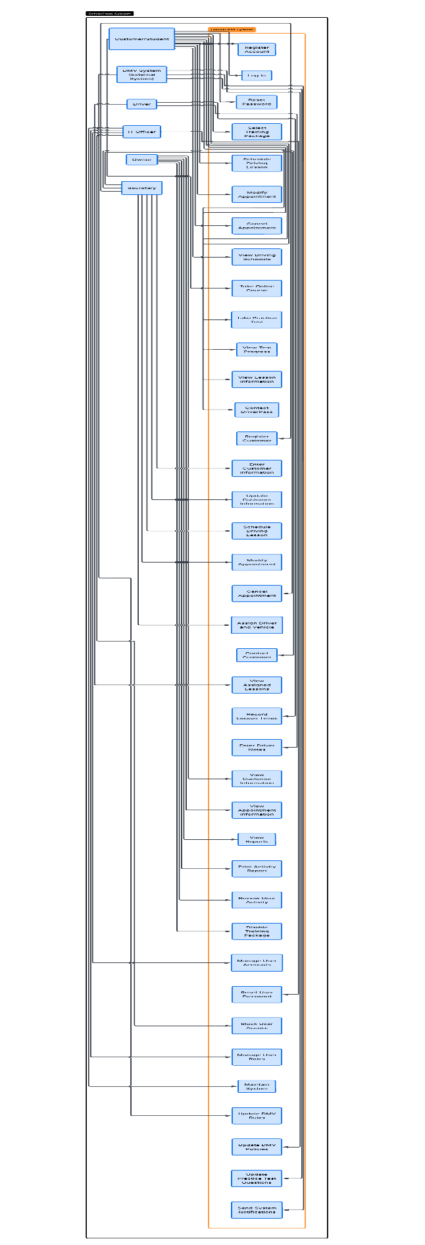

UML Activity Diagrams
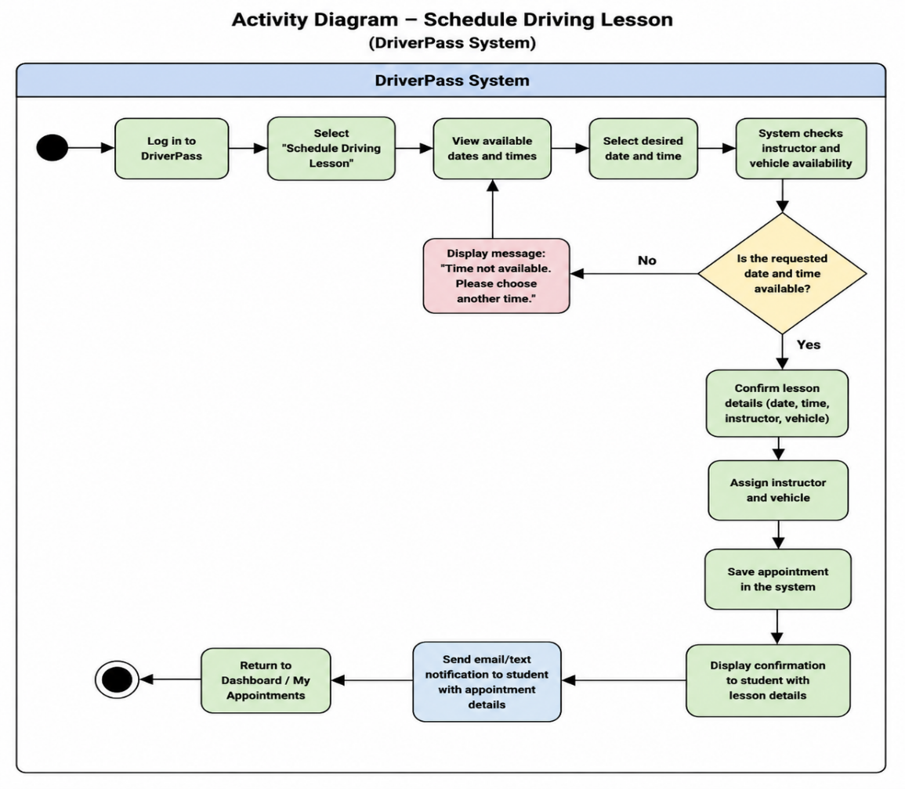
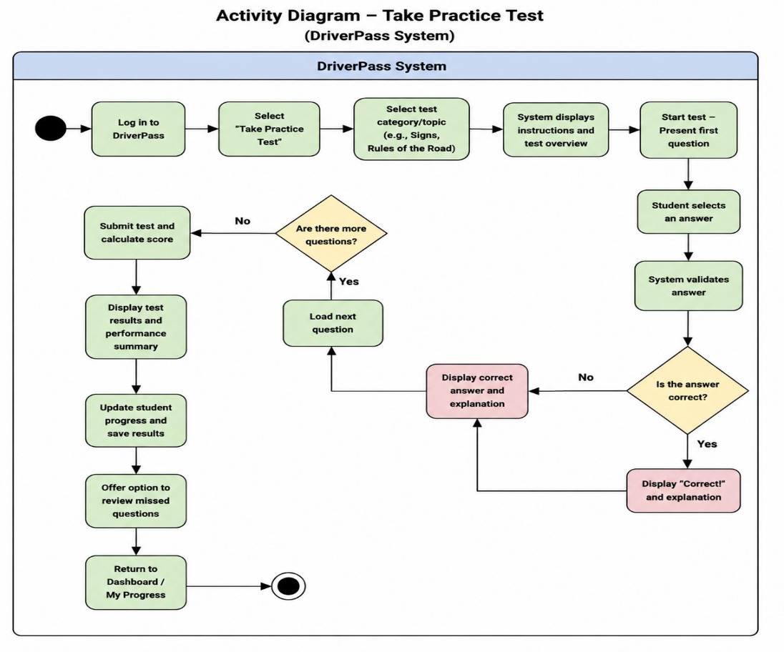

UML Sequence Diagram
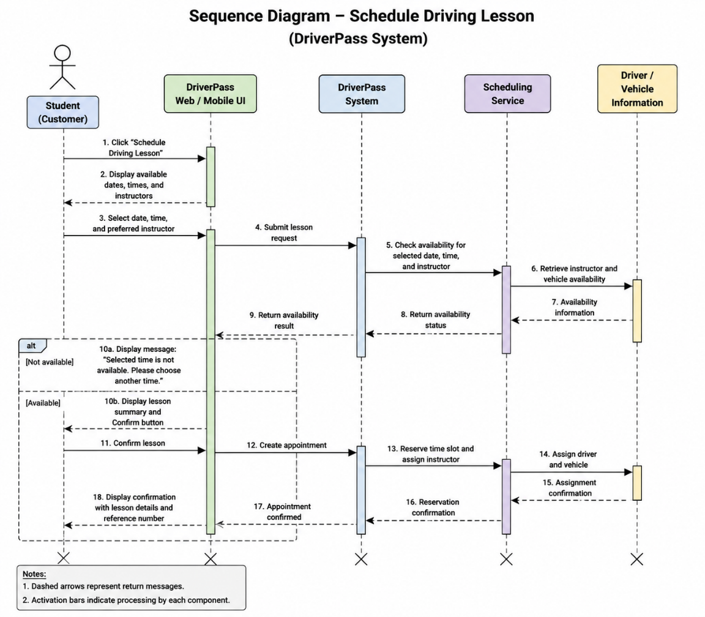

UML Class Diagram
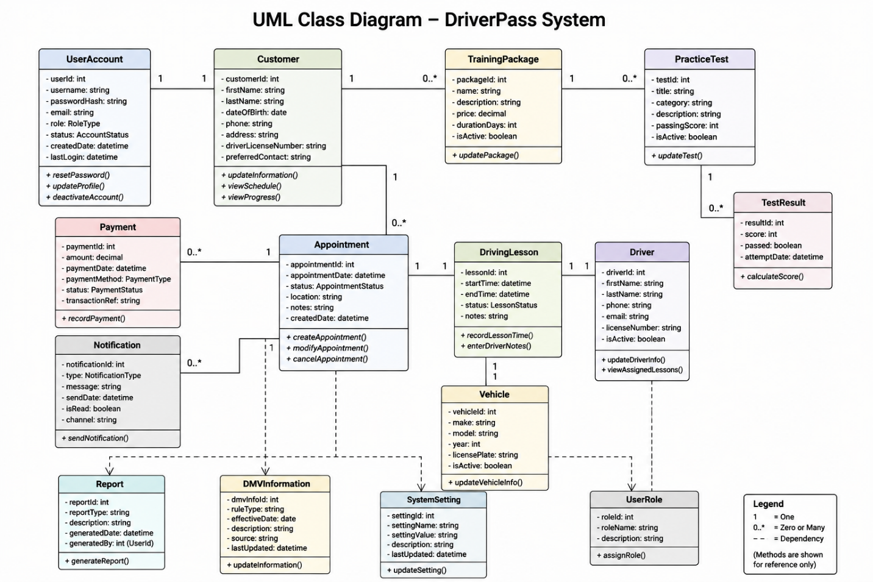

Technical Requirements

The DriverPass system will require reliable hardware, software, tools, and infrastructure to support both customers and employees. Because the system will be web-based, customers will need an internet-connected computer, tablet, or mobile device with a current web browser. DriverPass employees will also need computers with reliable internet access to manage customer information, appointments, training packages, reports, and other system functions.
The software will include a web-based application that allows customers to create accounts, select training packages, schedule driving lessons, take practice tests, and view their progress. Employees will use the system to manage appointments, customer information, drivers, vehicles, and user accounts. A database will be required to securely store customer information, account information, appointments, test results, training packages, and other records used by the system.
The system will require secure server or cloud-based infrastructure so that customers and employees can access DriverPass services online. A reliable internet connection will be necessary for communication between users and the system. Regular backups should be performed to protect information and allow data to be recovered if a system failure occurs. The system should also be designed to handle multiple users at the same time and allow future expansion as DriverPass gains additional customers.
Security tools will be necessary to protect customer and company information. Users will be required to log in with a username and password, and access should be limited based on each user's responsibilities. Sensitive information should be protected when it is stored and transmitted. The system should also maintain records of important user activity, allowing DriverPass to identify unauthorized access or changes.
Development and maintenance tools will be needed to create, test, update, and support the DriverPass system. These tools should allow developers to maintain the website, database, security features, and connections to external information such as DMV updates. The system should also support updates to practice test questions and DMV rules so that DriverPass can keep its training materials current.

